ONEWAY Memory BY HOS
/STATISTICS DESCRIPTIVES HOMOGENEITY WELCH
/PLOT MEANS
/MISSING ANALYSIS.

Oneway

Notes
Output Created |  | 05-May-2019 23:39:17
Comments
Input | Active Dataset | DataSet0
Input | Filter | <none>
Input | Weight | <none>
Input | Split File | <none>
Input | N of Rows in Working Data File | 30
Missing Value Handling | Definition of Missing | User-defined missing values are treated as missing.
Missing Value Handling | Cases Used | Statistics for each analysis are based on cases with no missing data for any variable in the analysis.
Syntax |  | ONEWAY Memory BY HOS  /STATISTICS DESCRIPTIVES HOMOGENEITY WELCH  /PLOT MEANS  /MISSING ANALYSIS.
Resources | Processor Time | 00 00:00:00.157
Resources | Elapsed Time | 00 00:00:00.175

[DataSet0]

Descriptives
Memory
 | N | Mean | Std. Deviation | Std. Error
Between 7-5 hours of sleep | 8 | 92.7750 | 28.53910 | 10.09009
Between 7-9 hours of sleep | 8 | 111.8925 | 39.94663 | 14.12327
Less than 5 hours of sleep | 7 | 104.8214 | 33.19535 | 12.54666
More than 9 hours of sleep | 7 | 65.8571 | 8.69609 | 3.28681
Total | 30 | 94.4030 | 33.66618 | 6.14658

Descriptives
Memory
 | 95% Confidence Interval for Mean |  | Minimum | Maximum
 | Lower Bound | Upper Bound | Minimum | Maximum
Between 7-5 hours of sleep | 68.9157 | 116.6343 | 55.50 | 140.00
Between 7-9 hours of sleep | 78.4963 | 145.2887 | 60.75 | 166.00
Less than 5 hours of sleep | 74.1208 | 135.5220 | 76.75 | 162.00
More than 9 hours of sleep | 57.8146 | 73.8997 | 48.00 | 75.00
Total | 81.8318 | 106.9742 | 48.00 | 166.00

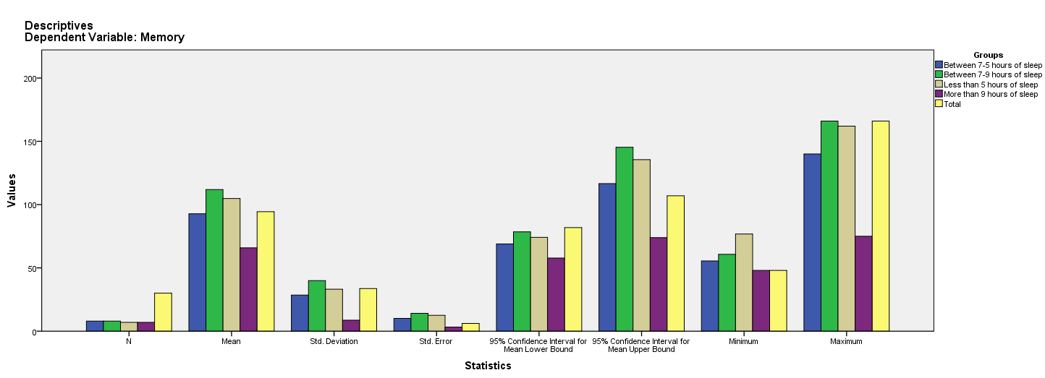

Test of Homogeneity of Variances
Memory
Levene Statistic | df1 | df2 | Sig.
4.598 | 3 | 26 | .010

ANOVA
Memory
 | Sum of Squares | df | Mean Square | F | Sig.
Between Groups | 8932.131 | 3 | 2977.377 | 3.234 | .038
Within Groups | 23936.814 | 26 | 920.647
Total | 32868.945 | 29

Robust Tests of Equality of Means
Memory
 | Statisticª | df1 | df2 | Sig.
Welch | 6.781 | 3 | 12.372 | .006
a. Asymptotically F distributed.

Means Plots

